SCIO TRUSTEES ANNUAL REPORT & FINANCIAL STATEMENTS
YEAR ENDED 31 DECEMBER 2021
Scottish Charity No. SC050041

Reference & Administrative Information

Charity Name: A-Team Productions

SCIO Scottish Charity No: SC050041

The Charities Principal Address: High Park, Main St East End, Chirnside, TD11 3XS

Charities Trustees on date of approval: Jackie Robinson, Chairman
Kenny Robinson, Treasurer
Marianne Hogg, Secretary

Bankers: The Royal Bank of Scotland
Edinburgh Stockbridge Branch
12 North-West Circus Place
EDINBURGH
EH3 6SX

Independent Reviewer: Anna-Marie McNaughton
34 Tirran Drive
DUNFERMLINE
KY11 8JG

Structure, Management & Governance
A-Team Productions is a Scottish Charitable Incorporated Organisation (SCIO) which operates under the Constitution that was formally adopted by the Members at the Meeting on 16th February 2020.

Appointment & Training of Trustees
A-Team Productions SCIO will actively recruit suitably skilled trustees and Office Bearers to strengthen and refresh the Team. In the event that one or more of the charity trustees resigns from their post, the remaining trustees will identify a potential successor(s). The Members will then be asked to vote on their appointment at the next AGM.
New trustees undergo induction and training in line with our Constitution and OSCR guidelines.

Objectives & Activities
Charitable Purpose: Under OSCR’s Definitions: 7. Charitable purposes; g; the advancement of the arts, heritage, culture or science
The objects of A-Team and the activities we carry out to achieve these are:
(a) Nurture and develop creative talents of young people in the Edinburgh area
(b) Develop young people’s knowledge of theatre skills and disciplines to create professional productions
(c) Facilitate opportunities for industry professionals to input into projects/productions
(d) Promote events by which aims, purposes and programme may be furthered

(e) Safeguard its purpose, aims and character and so to formulate and implement
development policies

We expose the members to all aspects of musical theatre, including working with live musicians and theatre professionals, to stage an annual musical theatre production. In doing so we will develop young people's knowledge of theatre, the skills and disciplines required to create a professional production. We use professional venues, equipment and production techniques in our shows, treat the young people with respect, as if they were professionals in this industry. In return we expect them to learn their lines, songs, movement etc, attend for rehearsal when called, ready to perform.

Achievements & Performance 2021
Things returned to something like normal during 2021 and we were able to stage our postponed show, in the much-reduced Edinburgh Festival Fringe. Whilst Little Shop of Horrors was a huge success for us, with almost every show selling out, it was very challenging to stage. To give us the best chance of avoiding Covid disruptions - to both the cast and audience – and to make sure we didn’t fall foul of any new legislation, we decided to stage it outdoors. It was a very successful show, the staging of which saw us achieved the following milestones:
- Formed a new cast, comprising of members previously cast in 2019 and new cast members
- Rehearsed for approx. 22 weeks – singing, dancing, acting and puppetry
- Entered into an agreement with Ocean Terminal for our unit. This gives us our own space for rehearsal, set building and costume storage etc. Ocean Terminal gave us the unit rent free and they pay our utilities. City of Edinburgh Council gave us 100% rates rebate, so the unit costs us nothing!
- We staged our first ever Fringe show, at an outside theatre, which we created, at George Watson’s College. It ran from the 9th to the 14th August
- We had a cast of 25 young people and an audience of over 1300 people
- We built 3 man-eating plants
- We had a visit from the Police – they interrogated the man-eating plant but let it go due to a lack of evidence!
- We were delighted to be invited to sing on-board the Royal Yacht Britannia during their Christmas Celebrations weekend

Our Year – In Pictures

Rehearsals in our own space at Ocean Terminal…

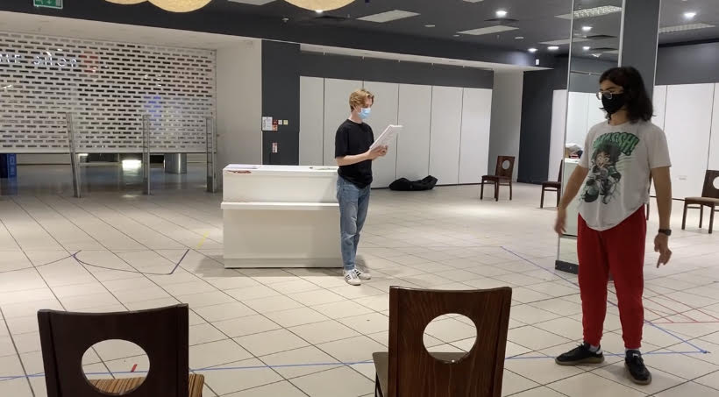

Our Window Display…
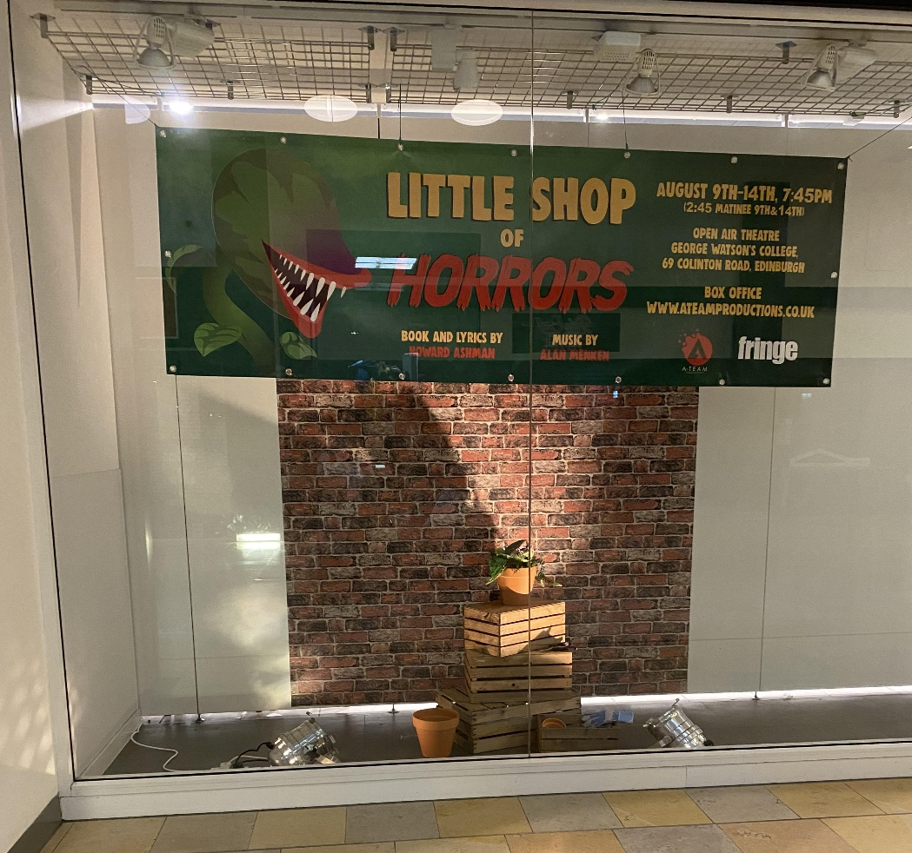

Giant Man-Eating Plant Building…Phase 1
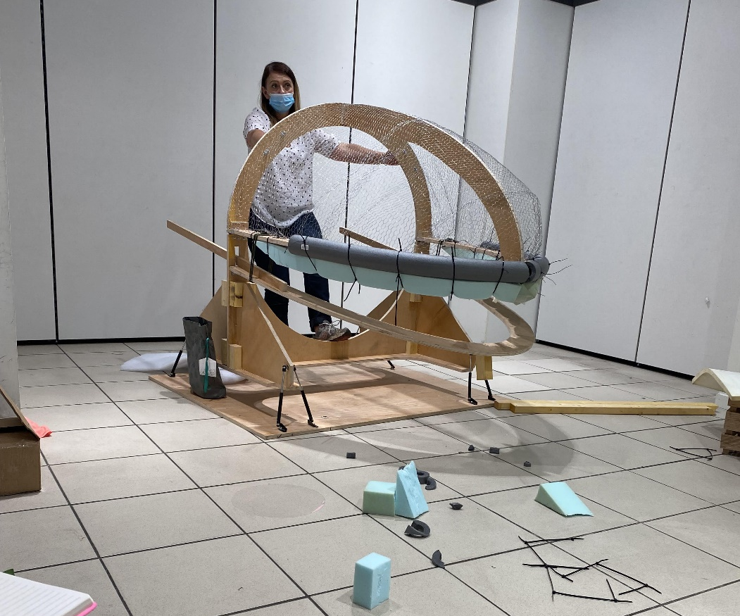
We had a visit from the Police…They were lovely!

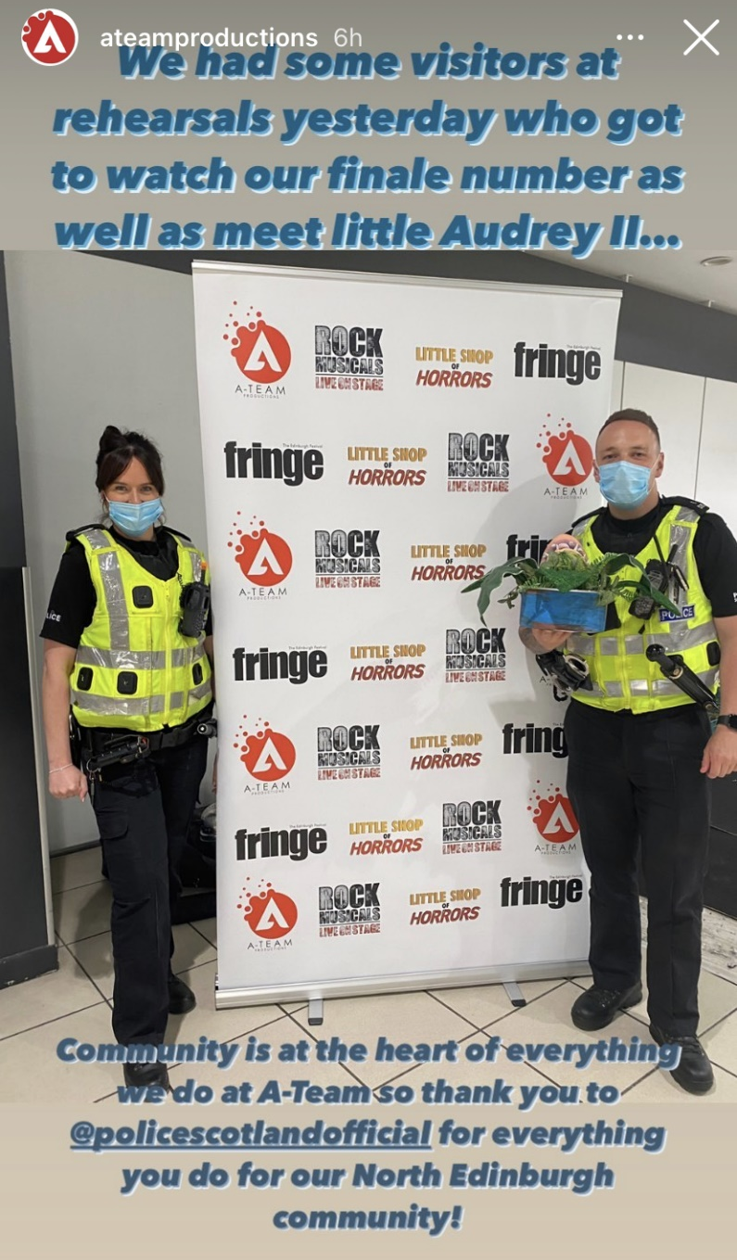

The Outdoor Theatre…It only rained once, phew!
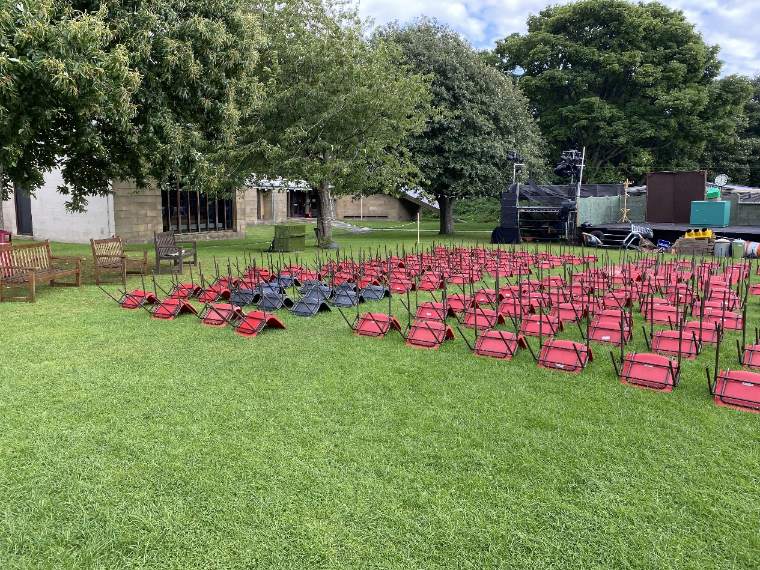

Show week’s finally here…

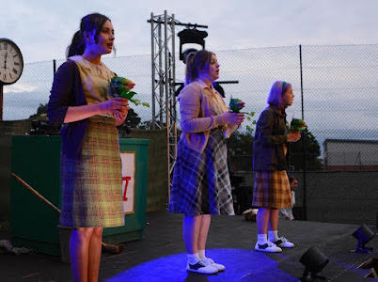

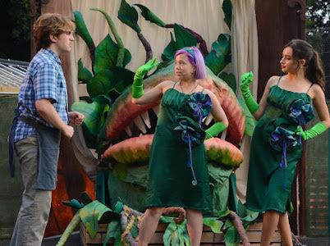

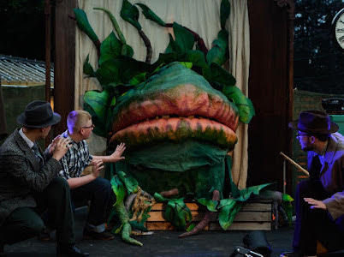

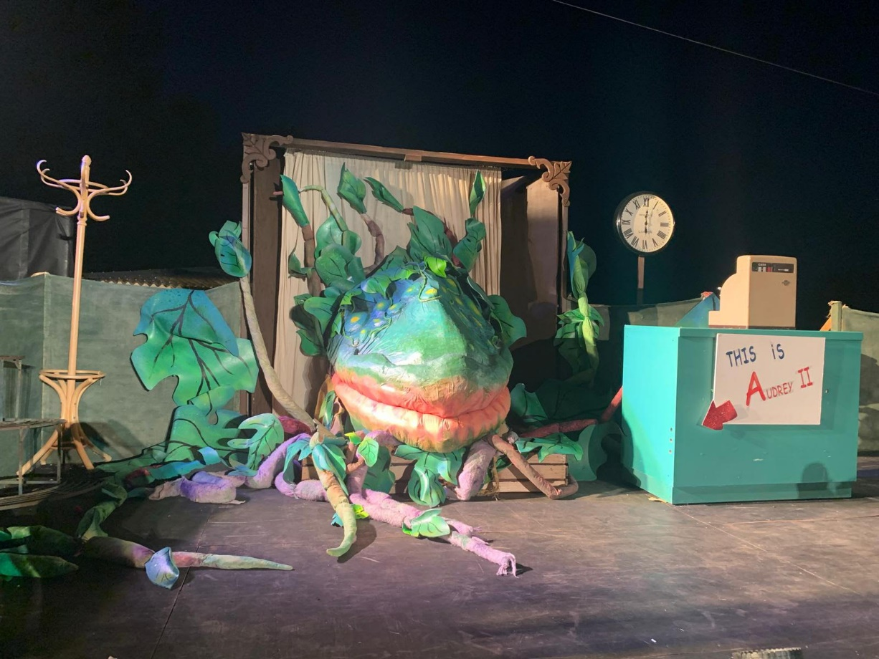

And before we know it, it’s over!
Our talented (and exhausted!) cast and crew…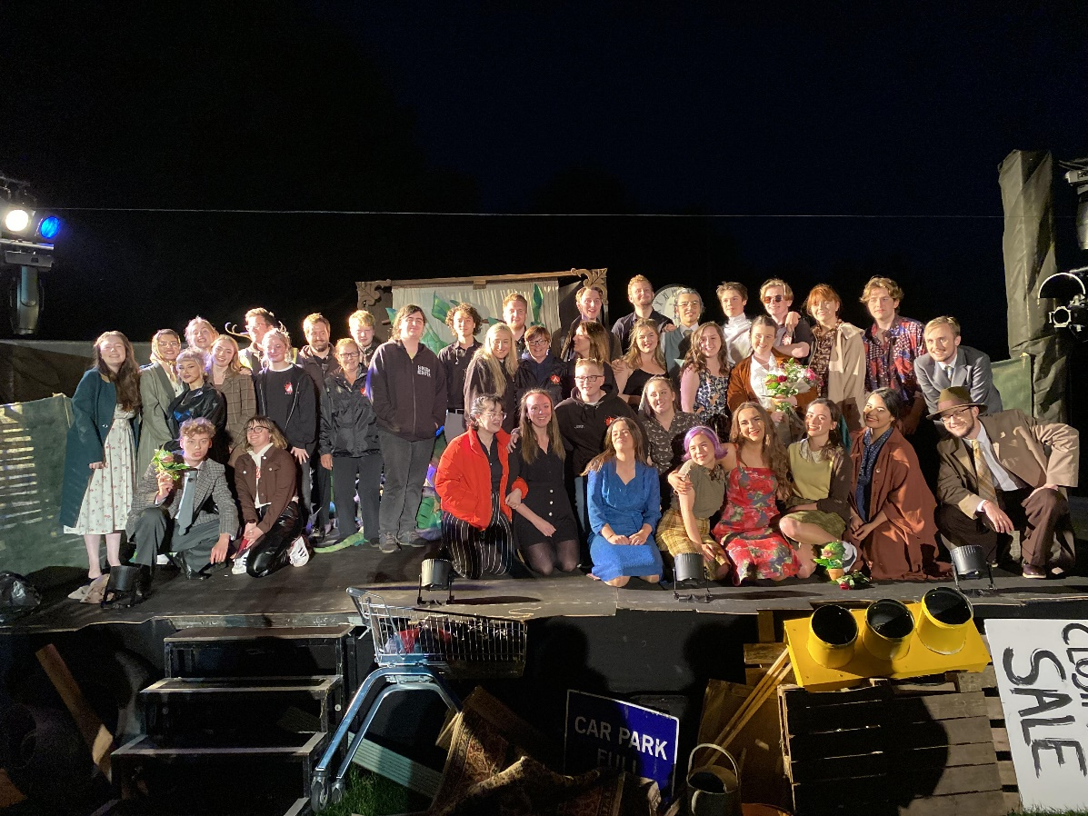

A lovely end to the year and an amazing experience…Christmas singing on the Royal Yacht Britannia

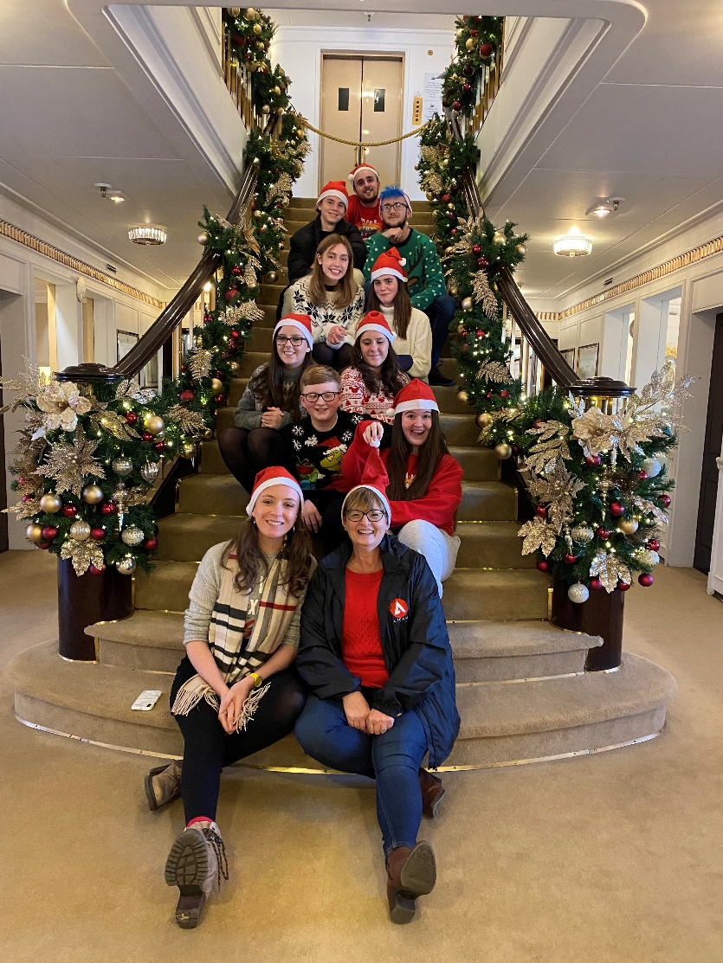
We have been incredibly lucky to work again with amazing volunteers. Without the support of all our volunteers, who provide their time, skills and enthusiasm, we would not be able to produce the shows we do. To all who have donated time, effort, money and company resources, many thanks, we are forever in your debt.
We are always looking for volunteers, and are actively seeking volunteers with fundraising, social media and marketing skills. If this is you, we would love to hear from you.
Contact: Jackie Robinson - Email: Jackie@ateamproductions.co.uk
We can also be found on:
Youth Theatre | A-Team Productions
A-Team Productions | Facebook
A-Team Productions (@ateamproductions) • Instagram photos and videos
Financial Performance
A set of Receipt and Payment Accounts were uploaded to the OSCR website for the year 01.01.21 – 31.12.21. These showed a deficit of £2,785, with our Statement of Balances showing a cash surplus of £10,154. This surplus will be carried forward and used to fund the 2022 production.

Financial Review & Reserve Policy
The charity’s policy on reserves is to hold no reserves. Whilst we appreciate that this is unusual, the work carried out by the charity is such that each production will be self-funding with the funds available dictating the show budget. The charity has no fixed costs such as salaries or rents etc so does not have to provide to cover these with reserves should the income be less than expected. This was borne out during 2020, when activities ceased and our deficit was less than £50.

This report was approved by the Trustees on 11th April 2021 and signed, electronically, on their behalf by Kenny Robinson, Treasurer

Kenny Robinson
10/04/2022

